Lab 8

**Problem Statement**

The problem is to be able to record a user’s voice and translate that into text. The user must also be able to type words and have the device read aloud the text back to them.

**Analysis**

I will create a mobile application with two button and an editable text field. The first button will trigger a dialog box to pop up that can record a person’s voice. When they are done talking, the translated Speech-To-Text will appear in a text field below the button. The second button will be disabled by default with some helpful text below it. Below that text will be an editable text field in which the user can type what they want to be read aloud to them. If there is at least one character in the editable text field, the second button will become enabled. When the user presses that button, the system will read aloud whatever text is in the editable text field.

Some difficulties were in testing because the Android emulator cannot record audio or play back audio.

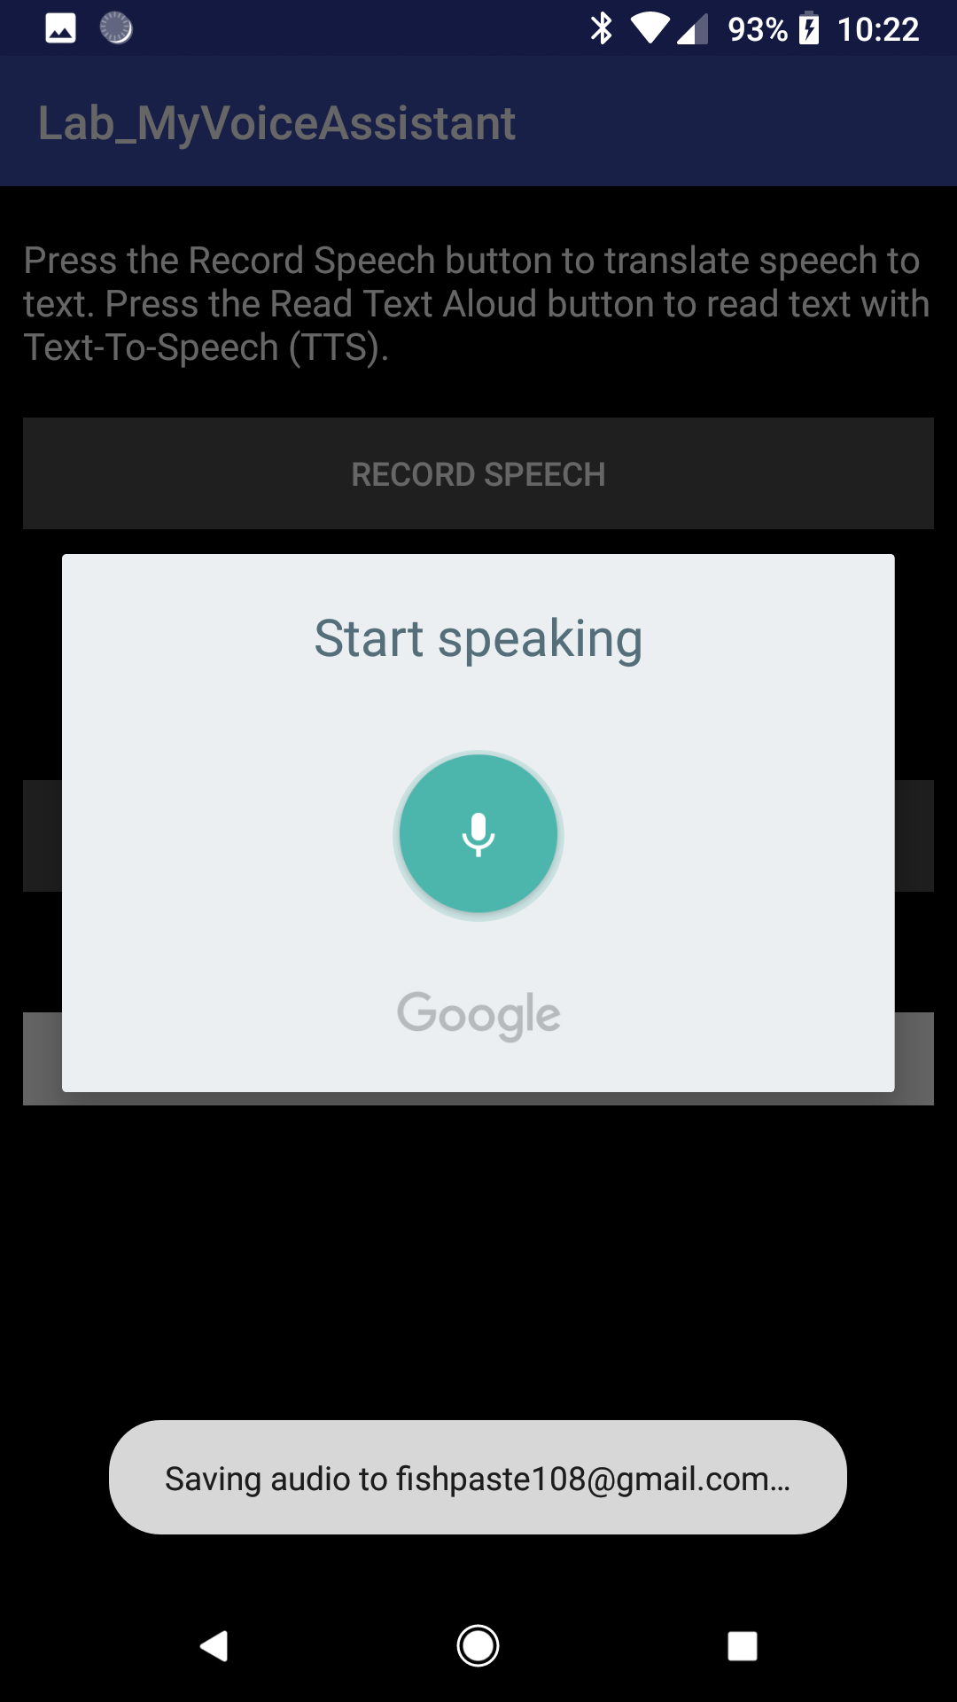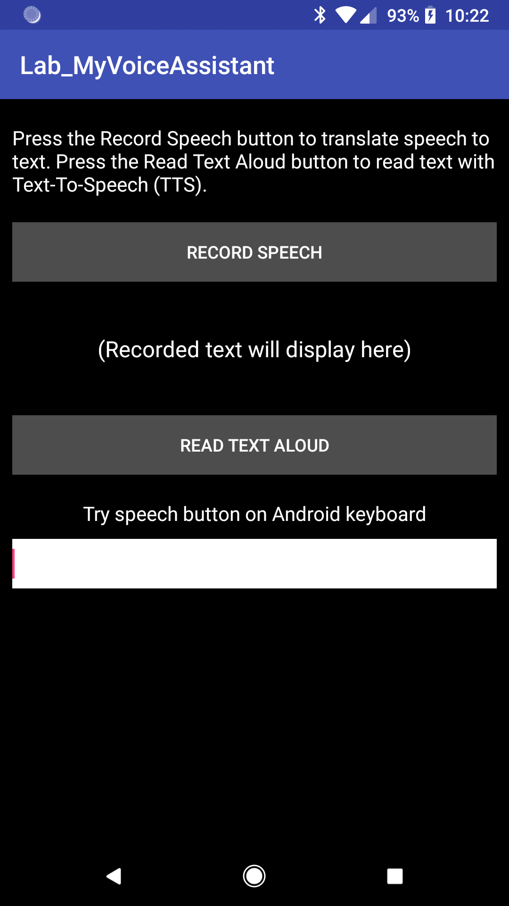**Screen Shots**

Figure 2: Dialog box that appears after pressing the first button (RECORD SPEECH)

Figure 1: Application on startup

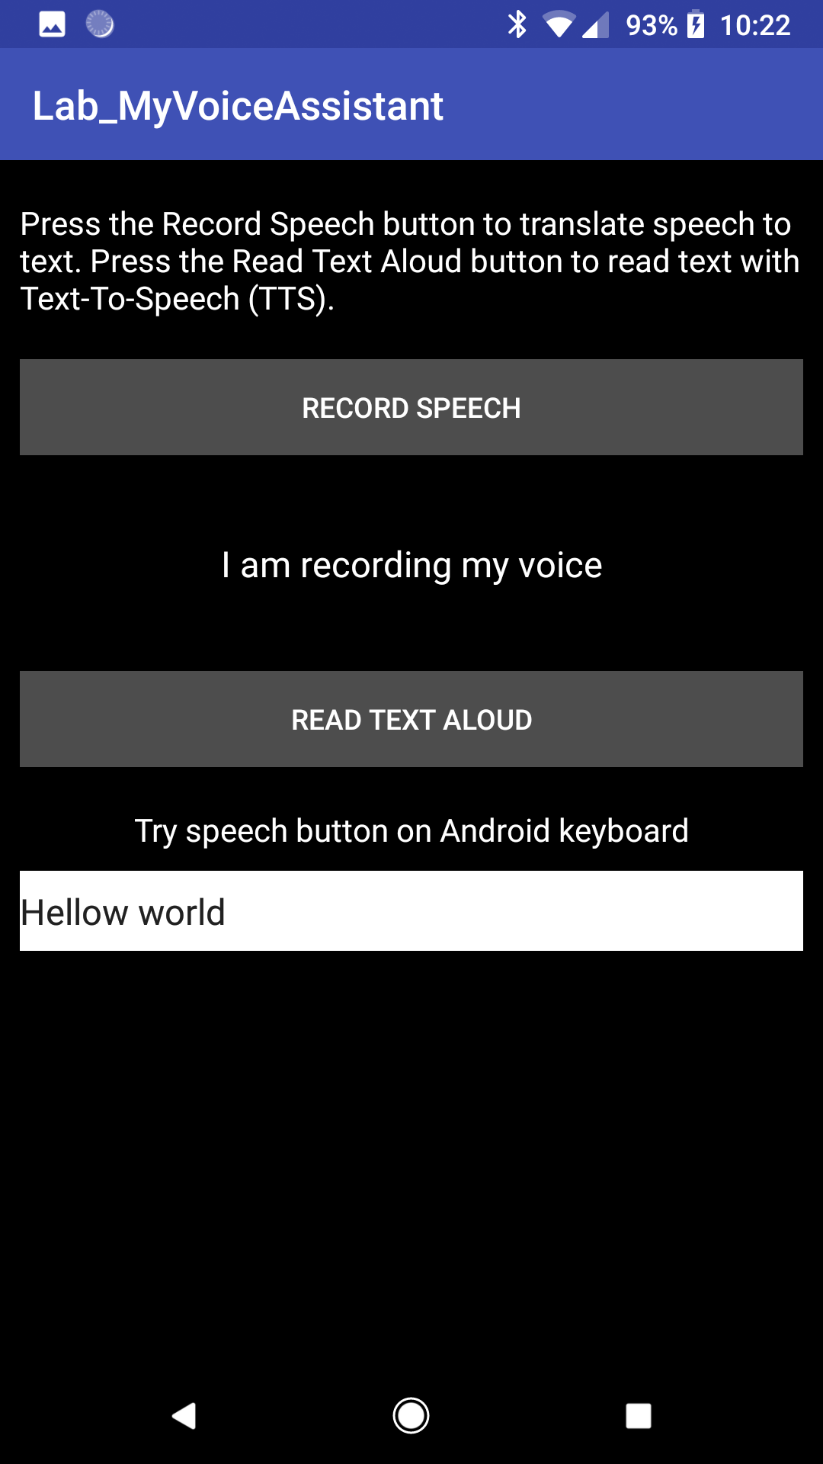 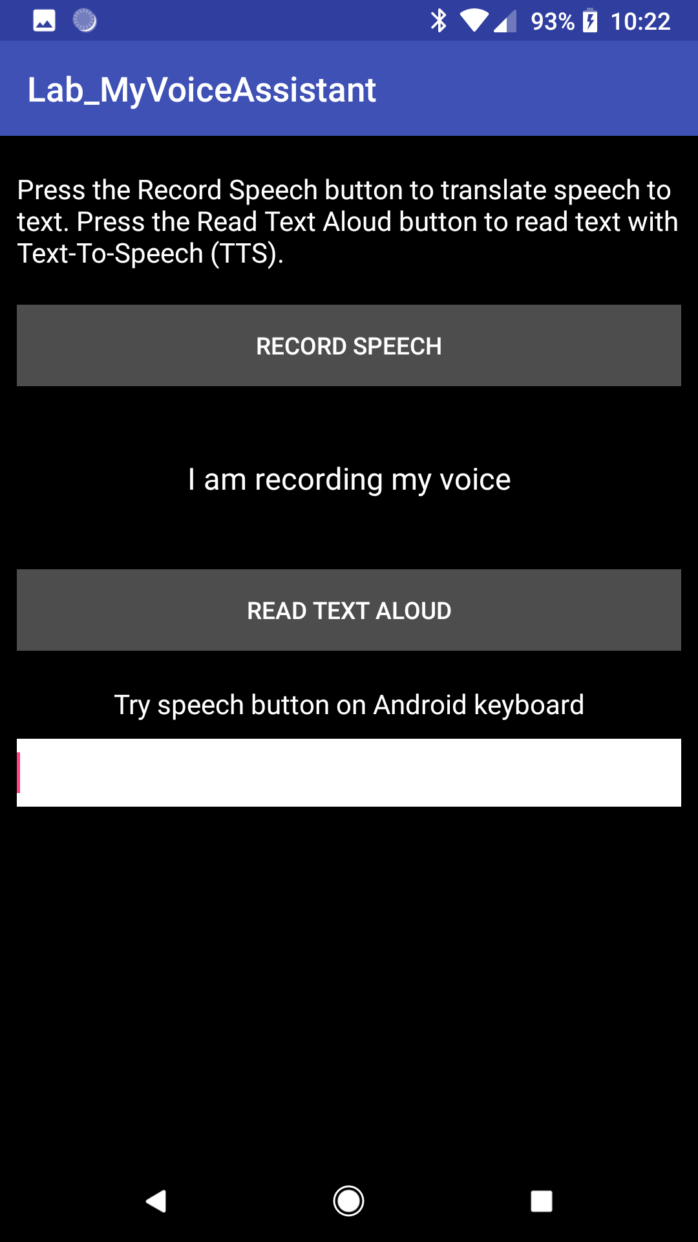

Figure 4: The user can enter text into the text field. When they press the READ TEXT ALOUD button, the text that will be read aloud is the contents of that text field.

Figure 3: The speech that was said during the dialog now appears as text below the RECORD SPEECH button

**Source Code**

Manifests/AndroidManifest.xml

*<?***xml version="1.0" encoding="utf-8"***?>*<**manifest xmlns:android="http://schemas.android.com/apk/res/android"  
 package="edu.wit.mobileapp.lab8_voice"**>  
  
 <**uses-feature android:name="android.hardware.microphone"** />  
 <**uses-permission android:name="android.permission.INTERNET"** />  
 <**uses-permission android:name="android.permission.RECORD_AUDIO"** />  
  
 <**application  
 android:allowBackup="true"  
 android:icon="@mipmap/ic_launcher"  
 android:label="@string/app_name"  
 android:roundIcon="@mipmap/ic_launcher_round"  
 android:supportsRtl="true"  
 android:theme="@style/AppTheme"**>  
 <**activity android:name=".MainActivity"**>  
 <**intent-filter**>  
 <**action android:name="android.intent.action.MAIN"** />  
  
 <**category android:name="android.intent.category.LAUNCHER"** />  
 </**intent-filter**>  
 </**activity**>  
 </**application**>  
  
</**manifest**>

java/ edu/wit/mobileapp/lab8_voice/MainActivity.java

**package** edu.wit.mobileapp.lab8_voice;  
  
**import** android.content.ActivityNotFoundException;  
**import** android.content.Intent;  
**import** android.os.Bundle;  
**import** android.speech.RecognizerIntent;  
**import** android.speech.tts.TextToSpeech;  
**import** android.support.v7.app.AppCompatActivity;  
**import** android.text.Editable;  
**import** android.text.TextWatcher;  
**import** android.util.Log;  
**import** android.view.View;  
**import** android.widget.Button;  
**import** android.widget.EditText;  
**import** android.widget.TextView;  
**import** android.widget.Toast;  
  
**import** java.util.ArrayList;  
**import** java.util.Locale;  
  
**public class** MainActivity **extends** AppCompatActivity {  
 **final int REQUEST_CODE** = 100;  
 **final** String **SPEECH_TAG** = **"SPEECH"**;  
  
 @Override  
 **protected void** onCreate(Bundle savedInstanceState) {  
 **super**.onCreate(savedInstanceState);  
 setContentView(R.layout.***activity_main***);  
  
 **final** Button speechToTextBtn = (Button) findViewById(R.id.***ButtonRecord***);  
 **final** Button textToSpeechBtn = (Button) findViewById(R.id.***ButtonRead***);  
 **final** EditText editTextField = (EditText) findViewById(R.id.***editTextField***);  
  
 *// Speech To Text* speechToTextBtn.setOnClickListener(**new** View.OnClickListener() {  
 @Override  
 **public void** onClick(**final** View view) {  
 **final** Intent intent = **new** Intent(RecognizerIntent.***ACTION_RECOGNIZE_SPEECH***);  
 intent.putExtra(RecognizerIntent.***EXTRA_LANGUAGE_MODEL***, RecognizerIntent.***LANGUAGE_MODEL_FREE_FORM***);  
 intent.putExtra(RecognizerIntent.***EXTRA_LANGUAGE***, Locale.*getDefault*());  
 intent.putExtra(RecognizerIntent.***EXTRA_PROMPT***, **"Start speaking"**);  
 **try** {  
 startActivityForResult(intent, **REQUEST_CODE**);  
 Log.*i*(**SPEECH_TAG**, **"Listening"**);  
 } **catch** (ActivityNotFoundException exception) {  
 Log.*e*(**SPEECH_TAG**, **"Could not start activity"**, exception);  
 }  
 }  
 });  
  
 *// Text to Speech* editTextField.addTextChangedListener(**new** TextWatcher() {  
 @Override  
 **public void** beforeTextChanged(CharSequence charSequence, **int** i, **int** i1, **int** i2) {  
 *// Do nothing. We don't care what the text was before.* }  
  
 @Override  
 **public void** onTextChanged(CharSequence charSequence, **int** i, **int** i1, **int** i2) {  
 **if** (charSequence.toString().isEmpty()) {  
 textToSpeechBtn.setEnabled(**false**);  
 } **else** {  
 textToSpeechBtn.setEnabled(**true**);  
 }  
 }  
  
 @Override  
 **public void** afterTextChanged(Editable editable) {  
 *// Do nothing. The state of the button is set anytime the text is changed. Not just when the user is done.* }  
 });  
  
 **final** TextToSpeech textToSpeech = **new** TextToSpeech(getApplicationContext(), **new** TextToSpeech.OnInitListener() {  
 @Override  
 **public void** onInit(**final int** status) {  
 **if**(status == TextToSpeech.***ERROR***) {  
 Log.*e*(**SPEECH_TAG**, **"Failed to initialize Text-To-Speech"**);  
 }  
 }  
 });  
 textToSpeech.setLanguage(Locale.*getDefault*());  
  
 textToSpeechBtn.setOnClickListener(**new** View.OnClickListener() {  
 @Override  
 **public void** onClick(**final** View view) {  
 Log.*i*(**SPEECH_TAG**, **"Reading aloud"**);  
 **final** String text = editTextField.getText().toString();  
 textToSpeech.speak(text, TextToSpeech.***QUEUE_FLUSH***, **null**, String.*valueOf*(**this**.hashCode()));  
 }  
 });  
 }  
  
 @Override  
 *// Called when the speech to text activity finishes* **protected void** onActivityResult(**int** requestCode, **int** resultCode, Intent data) {  
 **super**.onActivityResult(requestCode, resultCode, data);  
 **final** TextView textSaidView = (TextView) findViewById(R.id.***TextSaid***);  
 **switch** (requestCode) {  
 **case REQUEST_CODE**: {  
 **if** (resultCode == ***RESULT_OK*** && **null** != data) {  
 **final** ArrayList<String> result = data.getStringArrayListExtra(RecognizerIntent.***EXTRA_RESULTS***);  
 textSaidView.setText(result.get(0));  
 }  
 **break**;  
 }  
 }  
 }  
}

res/layout/activity_main.xml

*<?***xml version="1.0" encoding="utf-8"***?>*<**LinearLayout  
 xmlns:android  
 ="http://schemas.android.com/apk/res/android"  
 android:layout_width="fill_parent"  
 android:layout_height="fill_parent"  
 android:paddingLeft="10dp"  
 android:paddingRight="10dp"  
 android:gravity="top"  
 android:orientation="vertical"  
 android:background="#000000"** >  
  
 <**TextView  
 android:layout_width="fill_parent"  
 android:layout_height="wrap_content"  
 android:layout_marginTop="20dp"  
 android:textColor="#ffffff"  
 android:textSize="16sp"  
 android:text="@string/help"** />  
  
 <**Button  
 android:id="@+id/ButtonRecord"  
 android:layout_width="fill_parent"  
 android:layout_height="wrap_content"  
 android:layout_marginTop="20dp"  
 android:text="@string/button_record"  
 android:textColor="#ffffff"  
 android:background="#4d4d4d"** />  
  
 <**TextView  
 android:id="@+id/TextSaid"  
 android:layout_width="fill_parent"  
 android:layout_height="wrap_content"  
 android:gravity="center"  
 android:lines="5"  
 android:text="@string/recorded_text"  
 android:textSize="18sp"  
 android:textColor="#ffffff"**/>  
  
 <**Button  
 android:id="@+id/ButtonRead"  
 android:layout_width="fill_parent"  
 android:layout_height="wrap_content"  
 android:enabled="false"  
 android:text="@string/button_read"  
 android:textColor="#ffffff"  
 android:background="#4d4d4d"** />  
  
 <**TextView  
 android:layout_width="fill_parent"  
 android:layout_height="wrap_content"  
 android:layout_marginTop="20dp"  
 android:gravity="center_horizontal"  
 android:textSize="16sp"  
 android:textColor="#ffffff"  
 android:text="@string/try_help"**/>  
  
 <**EditText  
 android:id="@+id/editTextField"  
 android:layout_width="fill_parent"  
 android:layout_height="40dp"  
 android:layout_marginTop="10dp"  
 android:inputType="textCapSentences"  
 android:background="#ffffff"**/>  
</**LinearLayout**>

res/values/strings.xml

*<?***xml version="1.0" encoding="utf-8"***?>*<**LinearLayout  
 xmlns:android  
 ="http://schemas.android.com/apk/res/android"  
 android:layout_width="fill_parent"  
 android:layout_height="fill_parent"  
 android:paddingLeft="10dp"  
 android:paddingRight="10dp"  
 android:gravity="top"  
 android:orientation="vertical"  
 android:background="#000000"** >  
  
 <**TextView  
 android:layout_width="fill_parent"  
 android:layout_height="wrap_content"  
 android:layout_marginTop="20dp"  
 android:textColor="#ffffff"  
 android:textSize="16sp"  
 android:text="@string/help"** />  
  
 <**Button  
 android:id="@+id/ButtonRecord"  
 android:layout_width="fill_parent"  
 android:layout_height="wrap_content"  
 android:layout_marginTop="20dp"  
 android:text="@string/button_record"  
 android:textColor="#ffffff"  
 android:background="#4d4d4d"** />  
  
 <**TextView  
 android:id="@+id/TextSaid"  
 android:layout_width="fill_parent"  
 android:layout_height="wrap_content"  
 android:gravity="center"  
 android:lines="5"  
 android:text="@string/recorded_text"  
 android:textSize="18sp"  
 android:textColor="#ffffff"**/>  
  
 <**Button  
 android:id="@+id/ButtonRead"  
 android:layout_width="fill_parent"  
 android:layout_height="wrap_content"  
 android:enabled="false"  
 android:text="@string/button_read"  
 android:textColor="#ffffff"  
 android:background="#4d4d4d"** />  
  
 <**TextView  
 android:layout_width="fill_parent"  
 android:layout_height="wrap_content"  
 android:layout_marginTop="20dp"  
 android:gravity="center_horizontal"  
 android:textSize="16sp"  
 android:textColor="#ffffff"  
 android:text="@string/try_help"**/>  
  
 <**EditText  
 android:id="@+id/editTextField"  
 android:layout_width="fill_parent"  
 android:layout_height="40dp"  
 android:layout_marginTop="10dp"  
 android:inputType="textCapSentences"  
 android:background="#ffffff"**/>  
</**LinearLayout**>